**EXPERIMENT 13**

**Aim:** Study of Pulse Width Modulation and Demodulation.

**Apparatus Required:**

1. PWM Trainer - 01
2. Power Chord - 01
3. Patch Chords - 04
4. CRO - 01

**Procedure:**

1. Connect power chord to PM Trainer and switch ON the Trainer.
2. Message signal with various frequencies (500Hz, 1 KHz, 2 KHz) with variable amplitude are available in message signal section.
3. Connect CRO between anyone test terminal from P1 to P3 and GND Point to view the message signal with variable amplitude on CRO.
4. A Triangular wave carrier signal at various frequencies (64 KHz, 32 KHz, 16 KHz, 8 KHz) are available in carrier signal section.
5. Now Connect anyone message signal and carrier signal as an input to Pulse Width Modulator (P9 and P10) using patch chord.
6. The Pulse width modulation is done and the modulated signal can be tested using CRO with test point P12.
7. Patch the modulated signal in P12 with P15 in the demodulator section as a low pass filter input.
8. The filtered output is available at test Point P13 connect it with P14 test point
9. The final demodulated output is available at test point P18 and varies the pot meter to get amplified output.
10. Note down all the wave forms.

**BLOCK DIAGRAM:**

**PWM Modulation-**

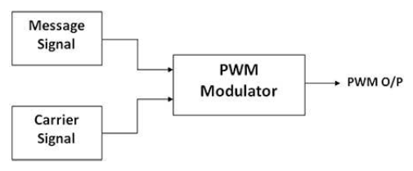

**PWM Demodulation-**

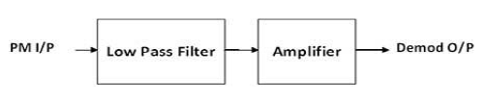

**Front Panel Diagram-**

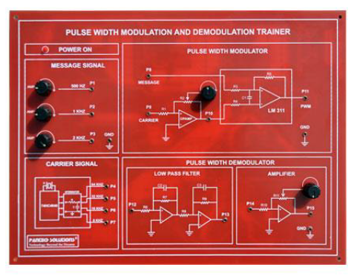

**Waveform-**

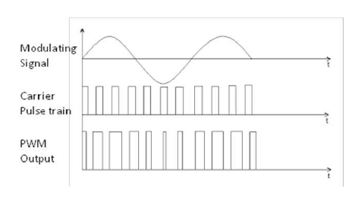

**Result:**

Thus, the Pulse Width Modulation and Demodulation was studied.